الجمهورية اللبنانية
وزارة التربية والتعليم العالي الامتحانات الرسمية لشهادة الامتياز الفني
المديرية العامة للتعليم المهني والتقني لدورة عام 2009 الثانية
===============
الاختصاص والرمز : المعلوماتية الادارية (24004) –الانظمة والشبكات (24101)
المادة : التطوير التطبيقي بالانترنت – البرمجة بلغة الانترنت المعدل: (8-6)
المستندات المسموح بها : لا شيء المدة : ساعة ونصف

N.B: All the "HTML" files are in the folder: \html
All the "AUDIO" and "VIDEO" files are in the folder: \sounds
All the "IMAGES" files are in the folder: \photo
All others files are in the folder: \misc

I- Write the appropriate tags to obtain as a result the following page " list.html", respecting the following conditions:  (4 pts)  - The Page title is «All Terrain Vehicle–ATV-Rent »  - Keywords for search engine are « ATV-RENT »  - Back color of the first table is yellow (Red and Green are given the maximum values and Blue is 50 % of value).  - The first table border colors are green and blue.  - Back color of the second table is green.  - Keep the page format. | 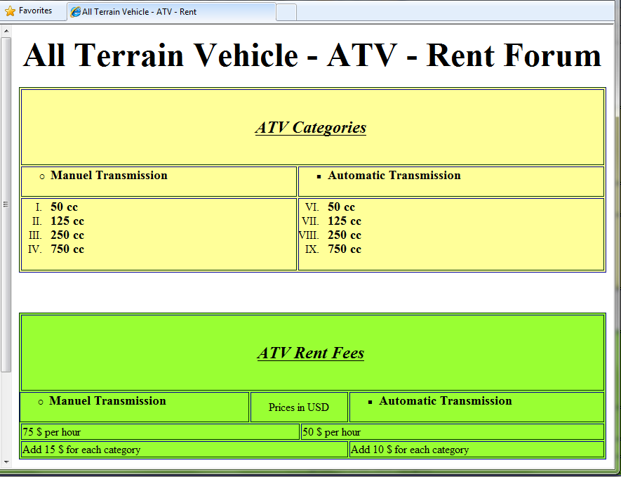
II- Write the appropriate tags to obtain as a result the following page «main.html», respecting the following conditions:  (4 pts)  - Page background color is light blue.  - The name of the first image is «atv.jpg ».The image border thickness is 3 pixels  - «Adventure of life» is a scrolling message from left to right infinite times with a white background.  - The music «rock.wav» is played when the mouse cursor is on top of the image «atv.jpg ».  - The name of the second image is «phone.jpg».  - A click on contact us or on the phone image will send an email to the following address «atv@atv.com.lb».  - Keep the page format. | 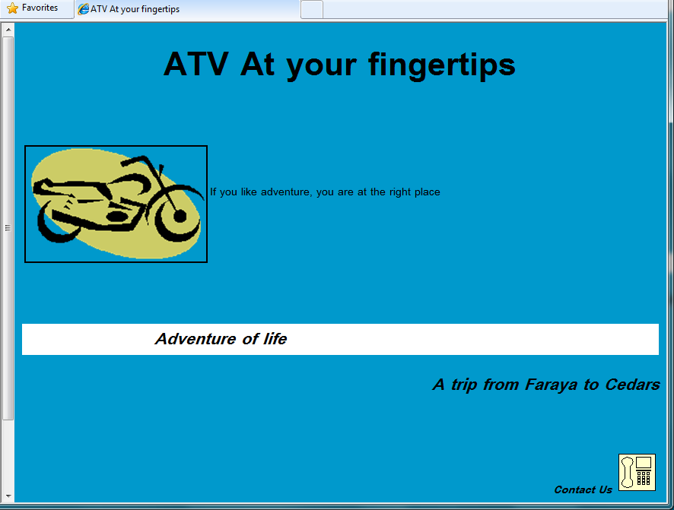
III-Name the two indispensable tags to create a web page HTML. (2 pts)

الاختصاص والرمز : المعلوماتية الادارية (24004) –الانظمة والشبكات (24101)
المادة : التطوير التطبيقي بالانترنت – البرمجة بلغة الانترنت المعدل: (8-6)

 | IV- Write the appropriate tags to obtain as result the following page "bookmark.html", respecting the following conditions:  (4 pts)  - First Name: Entry Field, 20 Characters. Viewable characters are 10.  - Last Name: Entry Field, 20 Characters. Viewable characters are 10.  - Address: Entry Field, 30 Characters.  - Type: Choice between Automatic and Manuel.  - Speed: Selection choice of 4 values: 50cc, 125 cc, 250cc and 750 cc. User can choose multiple values. Default selection is 750cc.  - Number of Hours: Entry Field, 2 Characters.  - Date: Entry Field, 2 Characters.  - New Ideas: Is a text box that contains 10 lines and 40 columns.  - A button Submit will send the data to the server using the script formbook.pl.  - A button Reset to restore the default values.  - « Download Available ATV» is a link that will download the file atv.xls. | 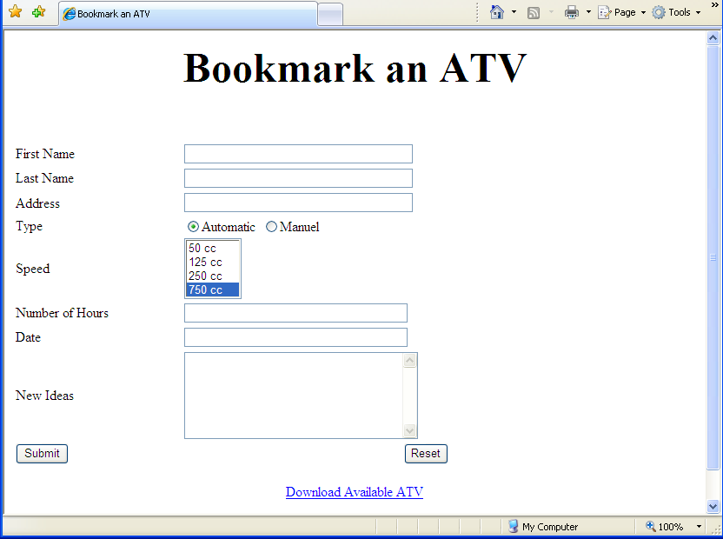

V- Write the appropriate tags to obtain as result the following page "index.html", respecting the following conditions: (6 pts)  - The hyper links should always have the blue color.  - This page is composed of four frames A, B, C and D.  - The first frame "A" hold the phrase «<Best viewed on Internet Explorer@ 8.0>”  - The second frame "B" display by default the page «main.html» of exercise II.  - The third frame "C" holds four links .The link « Main page» displays the page «main.html» of exercise II in the frame B. The link « ATV Categories » displays the page « list.html » section ATV categories of exercise I in the frame B. The link « ATV Rent fees » displays the page « list.html » section ATV Rent Fees of exercise I in the frame B. The link « bookmark » displays the page « bookmark.html » of exercise IV in the frame B.  - The fourth frame D displays the scrolling message «HTML» from left to right five times.  - Create all inexistent needed pages and add the needed tags to the preceding pages.  . | Frame A:  Width 100 %  Height:10%  Frame B:  Width: 80 %  Height: 80%  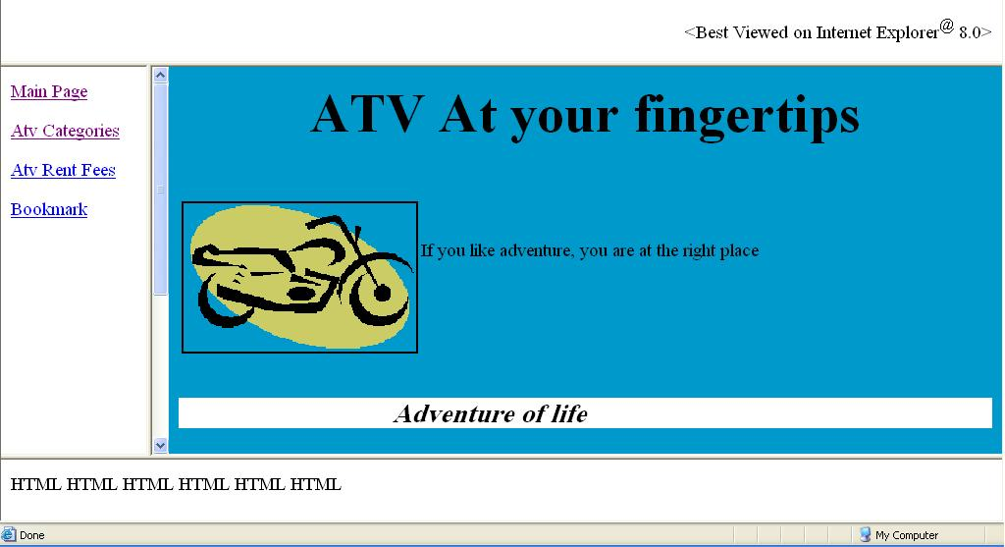  Frame C:  Width 20 %  Height:80%  Frame D:  Width 100 %  Height:10%

